**Shape of a distribution**

Contents

Skewness 1

Skewness 1

Positive Skewed /Right Skewed 1

Negative Skewed /Left Skewed 2

Kurtosis 2

Kurtosis 2

# Skewness

* Skewness measures **symmetry**
* Measures the extent to which data values are **not symmetrical**

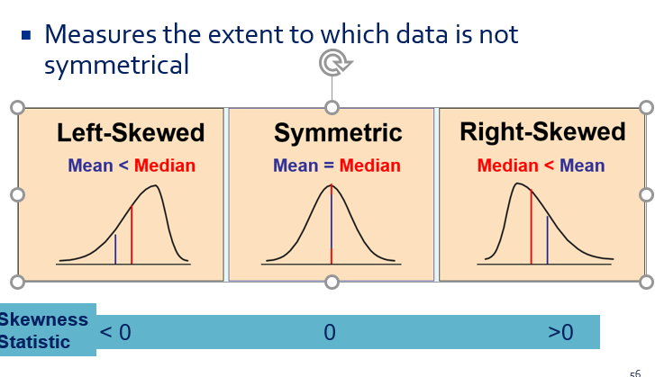

## Positive Skewed /Right Skewed ( Tail is on right side / positive side)

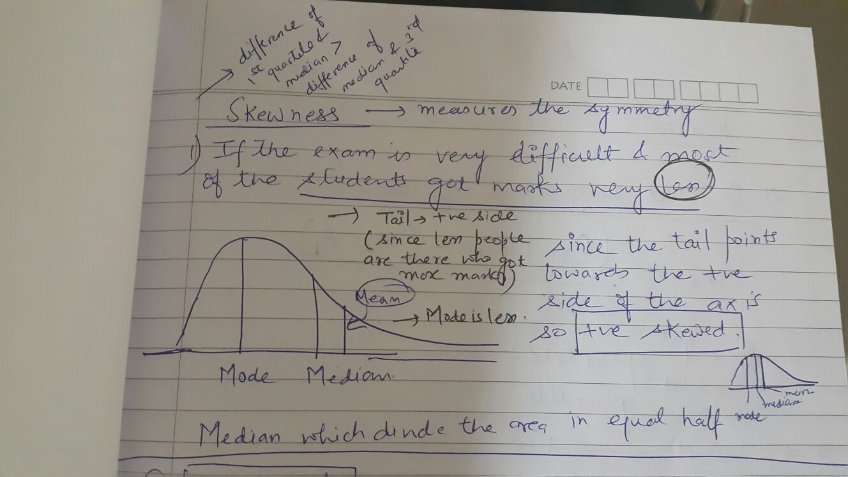

Example is Income which is mostly right skewed since most of the people are on the lower side of income but few people are very rich so they have very high income so they shuft the mean toward the right side

So Mode < Median < Mean

## Negative Skewed /Left Skewed

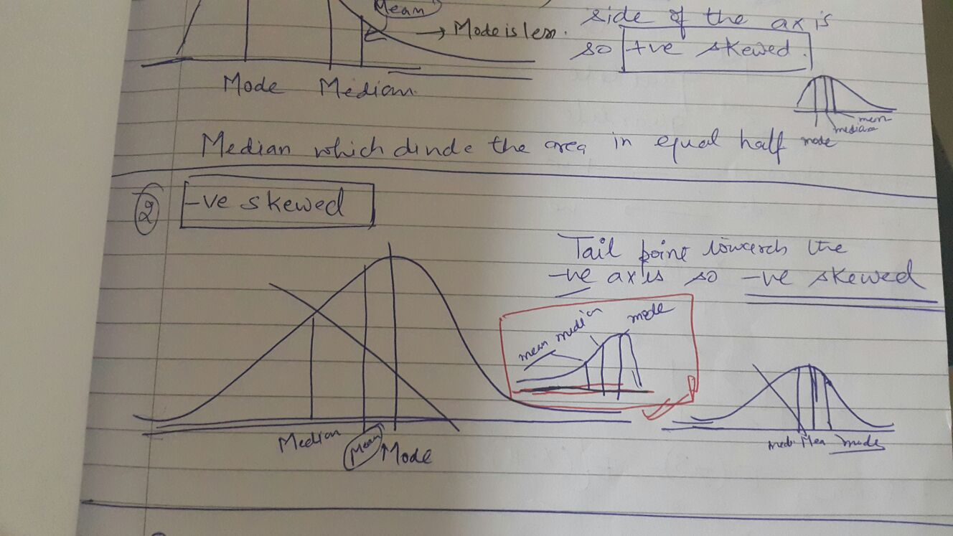

# Kurtosis

Kurtosis affects the **peakedness** of the curve of the distribution—that is, how sharply the curve rises approaching the center of the distribution

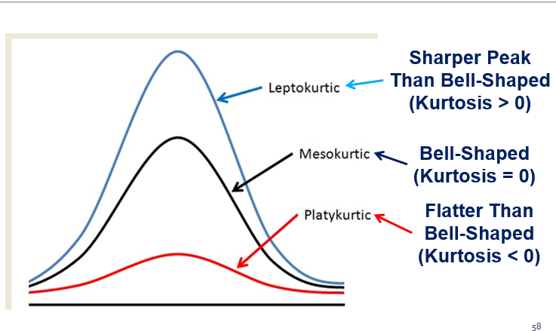

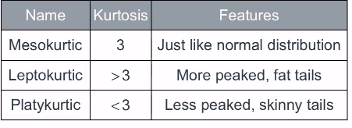

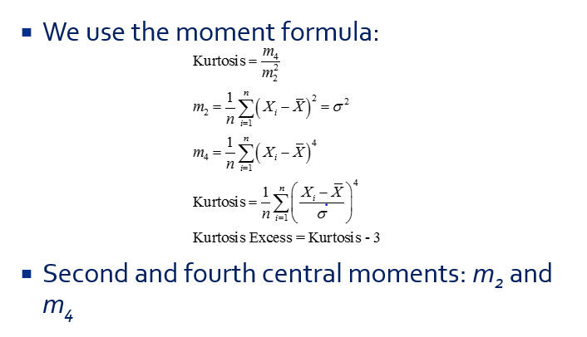

* A normal curve has kurtosis exactly equal to 3
* A kurtosis less than 3 (negative excess) indicates that the distribution has fewer outliers, so that its tail would be flatter
* A kurtosis more than 3 (positive excess) is the opposite situation

**========================================================================**